Ex. No. 4 | Collaboration Diagram
Date of Exercise

Aim
To draw a Collaboration diagram for on-line railway reservation system
Youtube link :
https://youtu.be/idMRMsq9BW8
Description
Like the other Behavioral diagrams, Collaboration diagrams model the interactions between objects. This type of diagram is across between an object diagram and a sequence diagram. Unlike the sequence diagram, which models the interaction in a column and row type format, the Collaboration diagram uses the free-form arrangement of objects. This makes it easier to see all iterations involving a particular object. In order to maintain the ordering of messages in such a free-form diagram, messages are labeled with a chronological number. Reading a collaboration diagram involves starting at message 1.0, and following the message from object to object.

Object
Objects are instances of classes, and are arranged horizontally. The pictorial representation for an object is a class (a rectangle) with the name prefixed by the object name (optional) and a semi-colon.

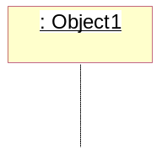

Actor
Actors can also communicate with objects, so they too can be listed as a column. An Actor is modeled using the ubiquitous symbol, the stick figure.
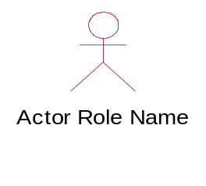
Lifeline
The Lifeline identifies the existence of the object over time. The notation for a Lifeline is a vertical dotted line extending from an object.
|
|
|

Activation
Activations, modeled as rectangular boxes on the lifeline, indicate when the object is performing an action.

Message
Messages, modeled as horizontal arrows between Activations, indicate the communications between objects.

Scenario of the application
The Collaboration diagrams includes the actors and classed needed for the development of the on-line railway reservation system. The actors are defined as classed with attributes and operations. This allows them to perform different functions on to the services provided to them. The operations are converted to the class structure and are linked depending on their relationship.

Collaboration Diagram for the application
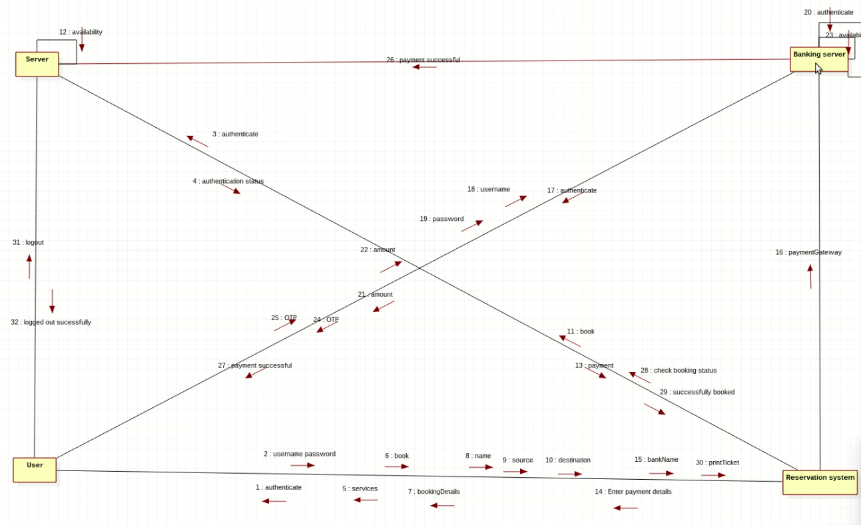
Functionalities of the objects used
Object name | Explanation
User | Acts as the customer who would be using the railway reservation system
Reservation System | Reservation system acts as an interface for the user to utilize the online railway reservation
Banking Server | The banking gateway ensures that the payment methods used bythe user are authentic and secure. This adds another layer of trust for the user.
Server | This server is the back end of the Reservation system UI. All the requests given out by the user are processed here.

Result
The collaboration diagram for on-line railway reservation system is completed and verified.

